User Criteria: table name user_criteria
User Criteria in ServiceNow is a powerful feature that allows you to control who can view, access, or interact with specific elements like Service Catalog items, Knowledge Base articles, and portal widgets. It defines "who" gets access based on conditions like user roles, companies, departments, locations, or custom scripts
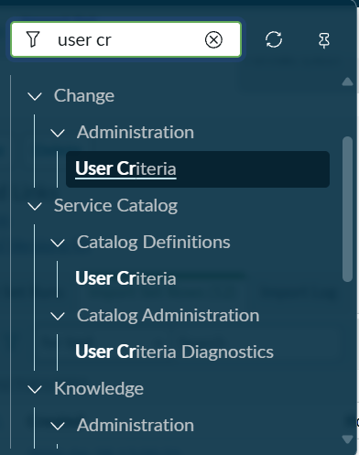
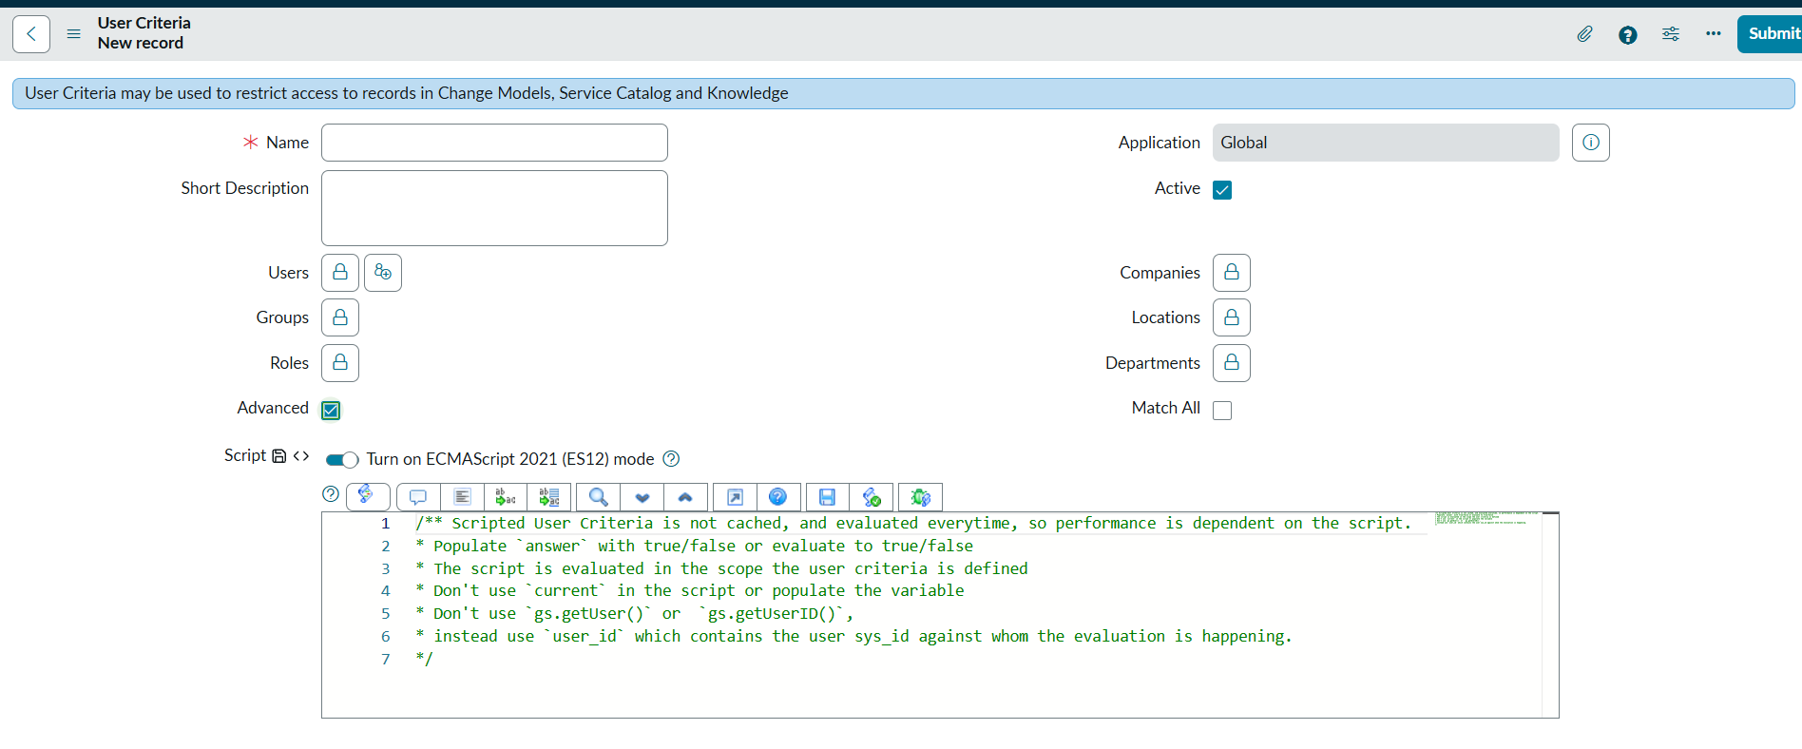
We make conditions like selecting user/group/roles etc
Or we write script.
We have a match all field ,if true all condition work as AND , if not true all will work as OR.
How to use it:
App Navigator -> maintain item
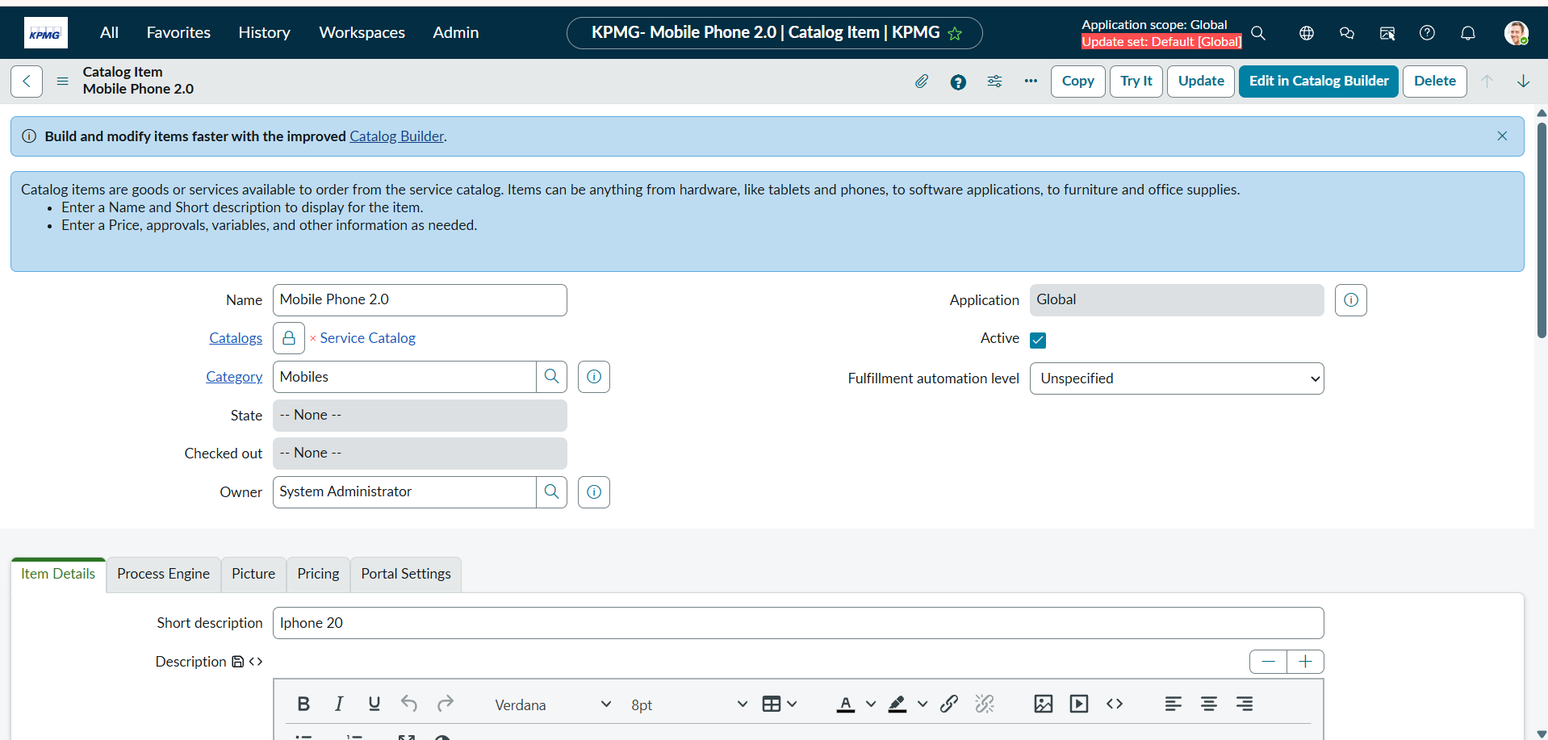
This is the catalog item below we see
Two related list
Available For and Not Available for
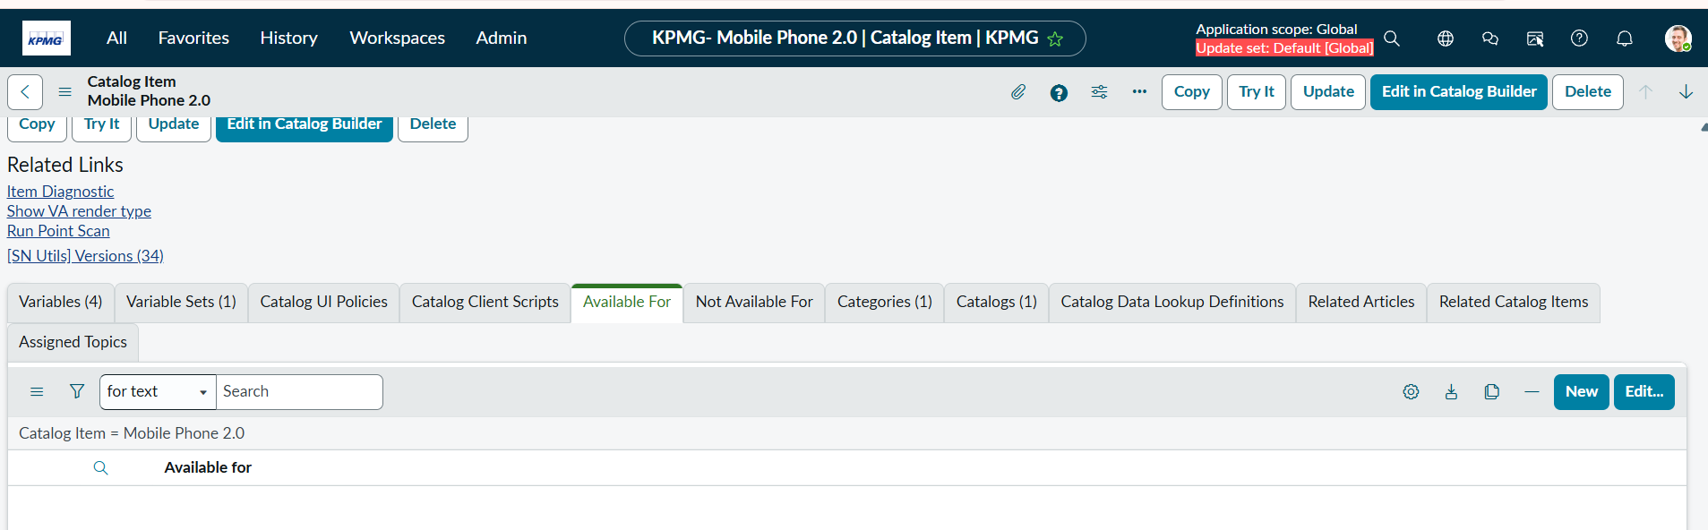
Simply we can add user criteria under them

